20/02/24 **Lecture 5: Recommender Systems**

Recommender Systems

Goal: Predict user preferences for an item

Strategies

* Content Filtering
* Collaborative Filtering

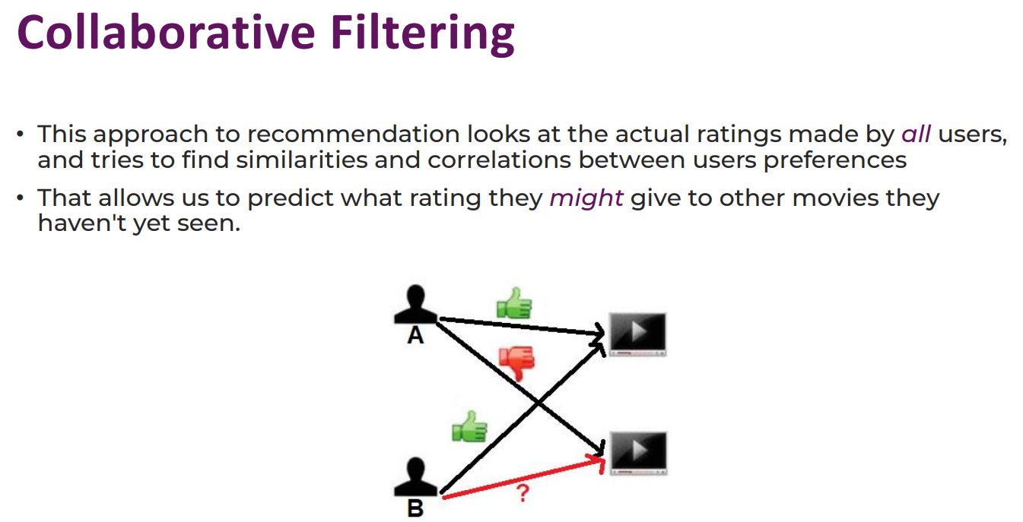

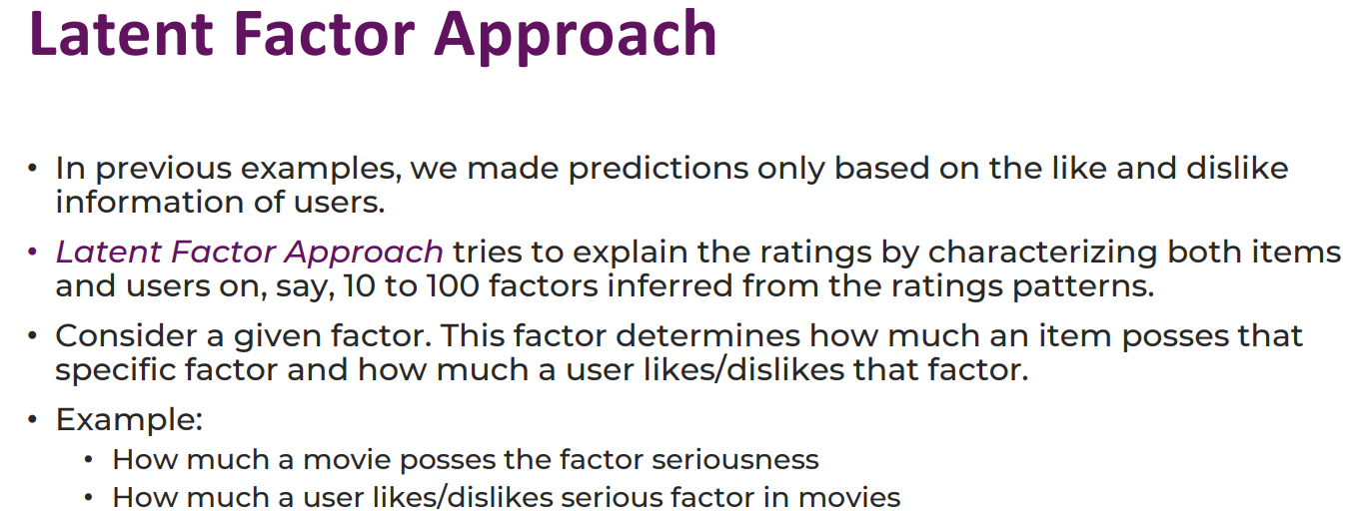

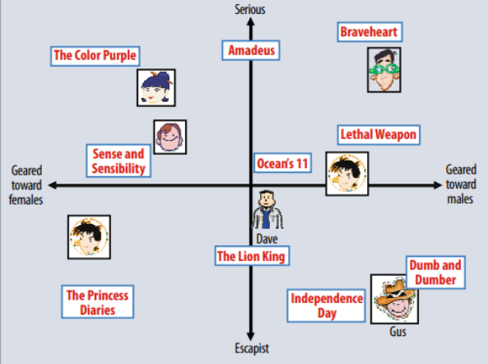

The latent factor approach is a machine learning method used to identify hidden patterns within a dataset. It simplifies complex datasets by identifying underlying factors that explain patterns. For example, in a recommendation system for movies, latent factors represent hidden characteristics of movies and users' preferences. This helps distill complex information into a smaller number of underlying factors, making it easier to understand and use for prediction or recommendation tasks.

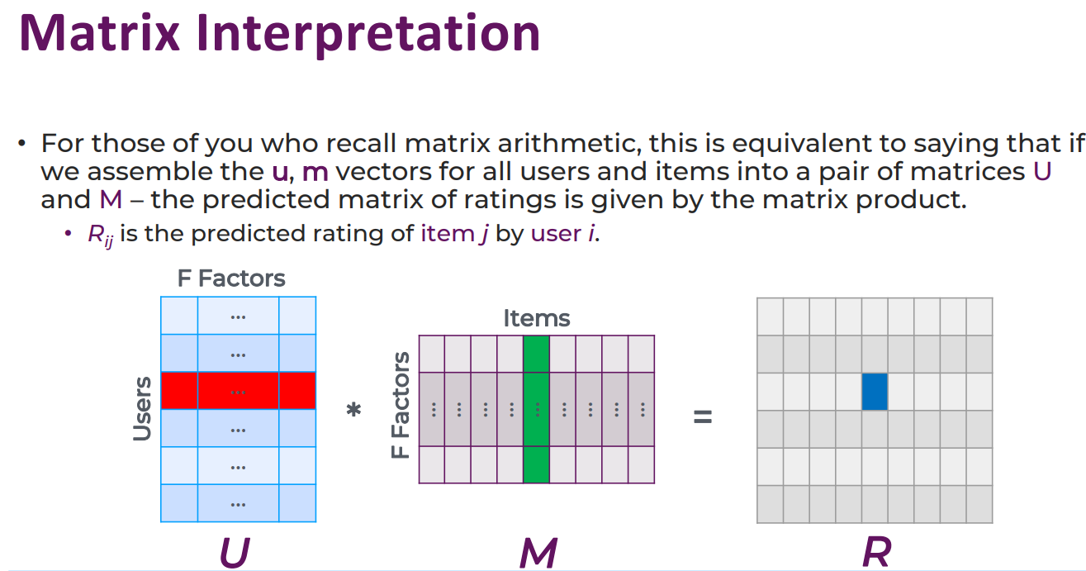

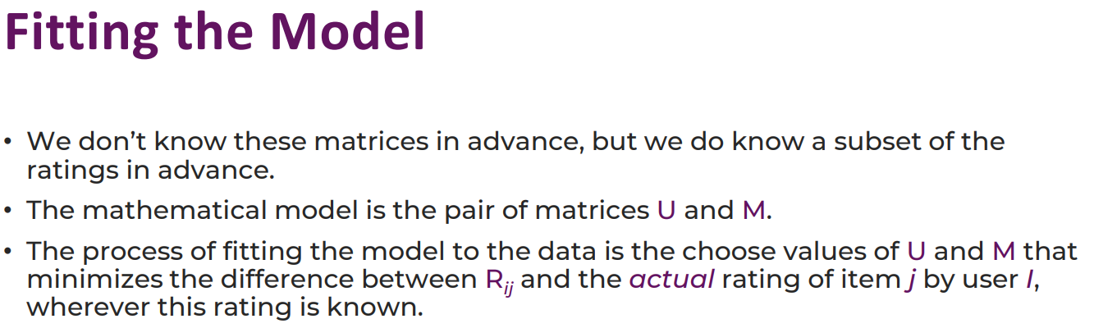

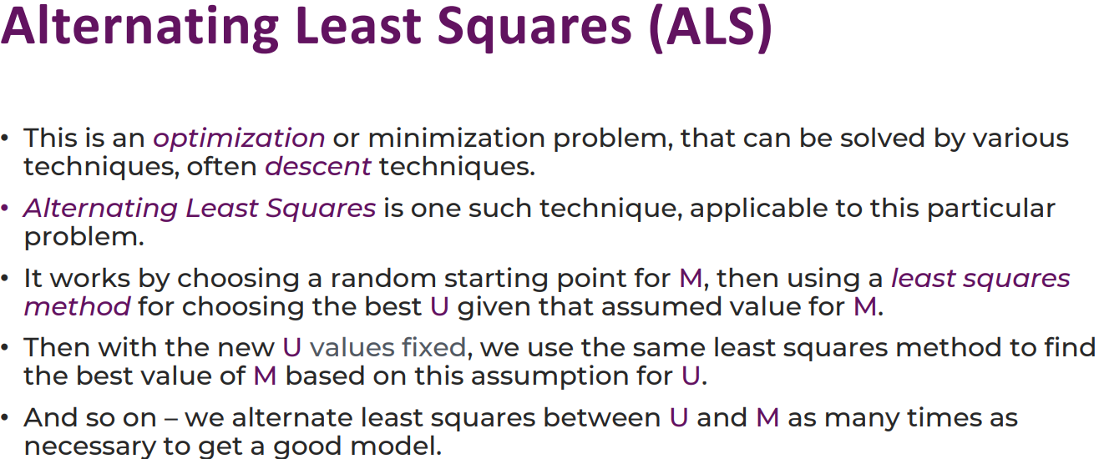

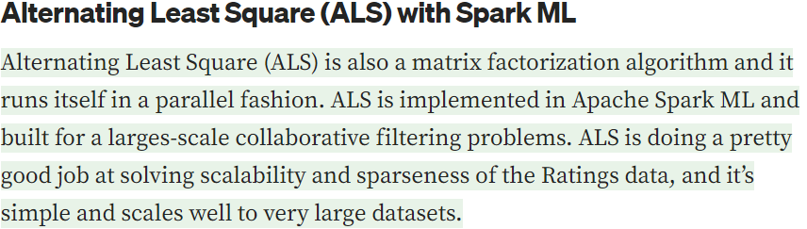

Alternating Least Squares (ALS) is an optimization algorithm used in collaborative filtering for recommendation systems, particularly for matrix factorization problems. It decomposes a large matrix into smaller matrices, aiming to minimize the difference between observed and predicted ratings. ALS alternates between optimizing one matrix while keeping the other fixed, repeating until convergence. It uses least squares optimization to minimize the difference between observed and predicted ratings. Regularization techniques are often used to control the complexity of learned latent factors and improve model performance.

